The Roaring Twenties
The decade following the end of the Great War was every bit the image of a bottle rocket launching into the night. Its ascent toward the stars carried with it the flare and excitement of an amazing and unimaginable future hinted at only in the pop of its cascading light; and, like the bottle rocket, the Roaring Twenties burnt out far short of the stars, consumed by its own fiery potential. The American economy boomed in the 1920s. New technologies—the car, electricity, and appliances like the clothes washer—made people’s lives and doing household chores easier. It gave people more free time, more time enjoy life’s leisure, to discover merriment in music, dance, and sports. Its brilliance, however, would continue to shimmer in eyes of and haunt an American people lost in the darkness of the Great Depression.
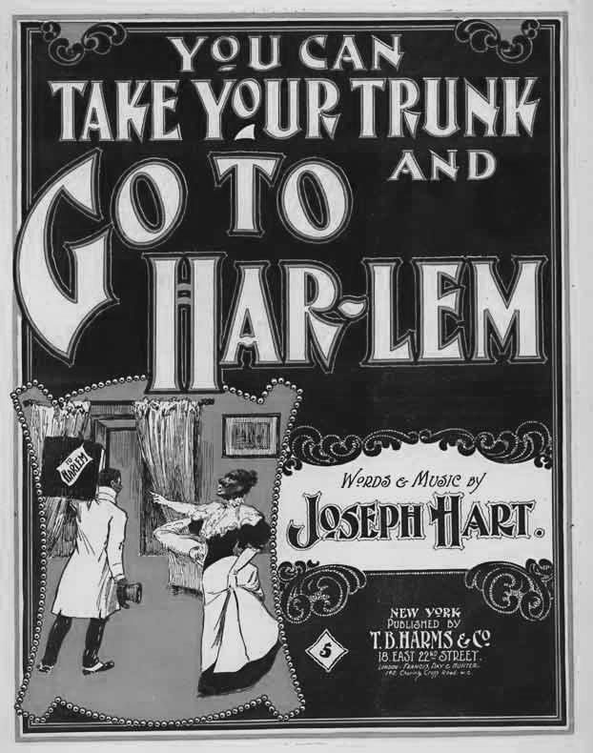
A Changing Society. The 1920s was an era of immense change—politically, socially, and economically. During the war, many people moved to the cities. Thousands of African-Americans from the South found well-paying jobs in factories of Northern cities like New York and Chicago, creating for the first time an African-American Middle Class. The Great Migration of African-Americans to North brought a new kind of music with them. Jazz music seemed to capture the tempo of the time. Harlem, a neighborhood in New York City, became the center of an explosion of African-American culture. Jazz, art, and literature flourished.
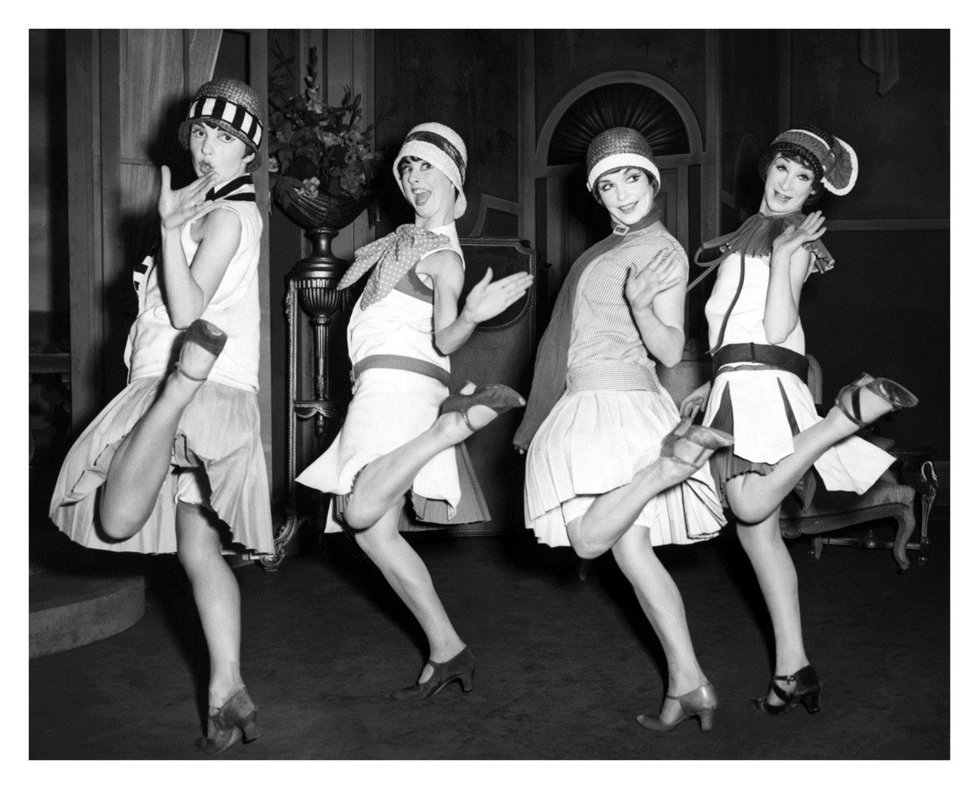
Women, too, found work in the factories and discovered a new independence and self-reliance. They did things they had never done before. They worked outside their homes. They went to college and played sports. Finally and most importantly, they were given the right to vote. From this, a new kind of woman was born—the Flapper—who pushed the rules of what society thought a young woman should be or how she should act. The American woman was declaring her right to be what she wanted, and the Flapper was rebellious, fun-loving, and care-free.
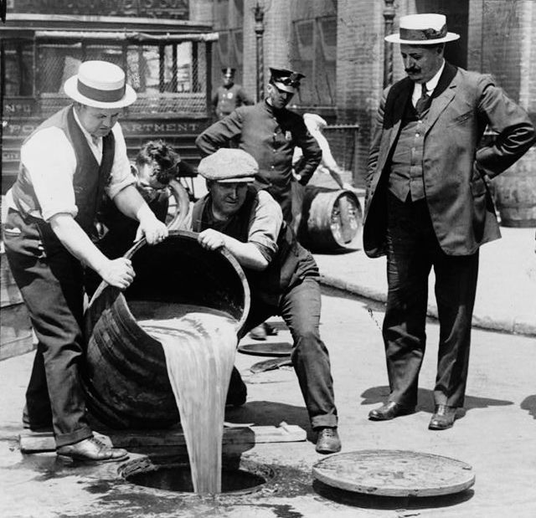
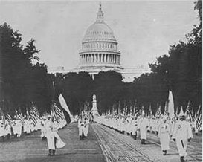
Problems of the 1920s. For all the excitement of the 1920s, it was also a decade of racial, political, and economic tensions. In 1919, race riots broke out in major cities across the nation. The Ku Klux Klan spread hatred and prejudice against African-Americans and other groups, they often attacked and killed people they thought were “un-American,” though it was hardly unpopular. Nearly 250,000 Americans were members and President Warren G. Harding was even inducted while in office as President of the USA.
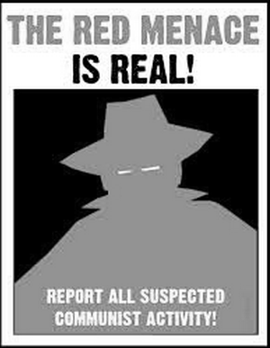
Also, in 1917, the Eighteenth Amendment to the Constitution made selling and drinking alcohol against the law. This was called Prohibition. Criminals like Al Capone made millions by dollars producing and selling it. The illegal activities led to violence and America’s gangster era.
Furthermore, anarchists, people who believe there should be no government, frightened Americans with a series of bombings in New York City, Seattle, and other cities. Soon political extremists of all kinds, including Communists, became the target of political persecution. More than 10,000 were arrested, hundreds were deported and expelled from the USA. Since “red” was a popular term for Communists, this era became known as the Red Scare.
Lastly, with World War I over, the Allies no longer needed help from American supplies—particularly American crops. Some farmers could not earn enough money to pay back money they borrowed. Many had to sell their farms.
- How did new technologies change lives after World War I?
- Why is Harlem important to African-American culture?
- Who were the flappers?
- What was Prohibition?
- Who are anarchists?
- What was the Red Scare?

