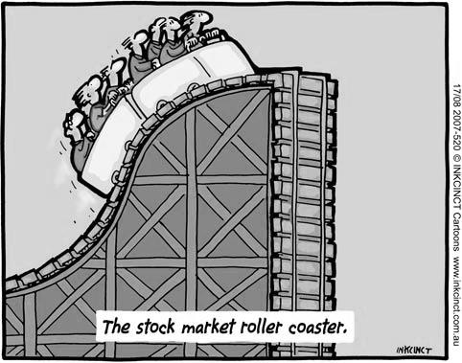
The Great Depression
The 1920s was a decade full of cultural and artistic expression in America. America had emerged from WWI richer, more powerful, and more confident than ever before. The Jazz Age was in full swing and Americans were pushing the boundaries of society placed on women and African-Americans in speakeasies across the country. It was a carefree and reckless time that was about to be swallowed by a deep dark hole…
Never had the highs been higher (1920s) or the lows lower (1930s) for America. The Great Depression—the worst economic crisis in the country’s history—left a scar on America’s society and culture, causing millions of people to suffer in joblessness, homelessness, and starvation for nearly a decade.
In an American culture that measured self-worth by success, many breadwinners from the Roaring Twenties felt deep humiliation and shame when they found themselves unable to put food on their family’s table.
The Great Depression in the United States spiraled out of control causing a major worldwide depression, as almost every industrialized economy—Britain, France, Germany, Italy, Japan, and others—were brought to their knees in the 1930s. The US Government, led by President Herbert Hoover at the time, refused to provide any direct help to the people. Because of this, many Americans began to blame President Hoover for the Depression, even though the wheels of the Depression had been in motion long before Hoover became President.
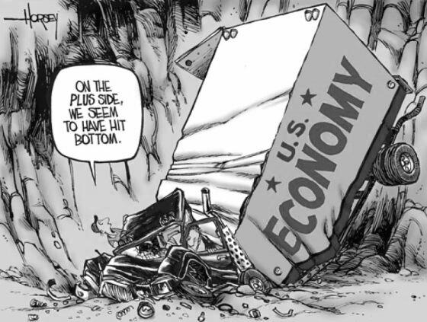
It was not until the Presidency of Franklin Delano Roosevelt (FDR) did the USA begin its long, slow process out of the Depression. FDR’s New Deal policies and programs provided relief, recovery, and reform to the average American. But it would take more than the New Deal alone to end the Depression. More than ten years after the Stock Market Crash of 1929, millions of Americans were still hungry, homeless, and unemployed. America’s depression ended only after Germany invaded Poland in 1939. With Europe at war again in the second world war, American industries were able to rev up their factories once again. Supplying our Allies with wartime goods such as ships, tanks, and weaponry gave the US economy the jump start it needed.

