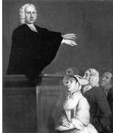
The Great Awakening Name_______________________________ PD_____
- The Great Awakening was a religious_______________________________.
- ______________________ was one of the primary pastors from America.
- ____________________________ was a minister from England. He was very ___________________________.
- Ministers in the colonies called for a ________________________ or return to strong faith.
- The Great Awakening created a greater ________________________ and __________________________ freedom in the colonies.
- Church went from ______________________ to _____________________.
- Belief that all people are ___________________________ grew.
- Colonists started to challenge _________________________ and speak their ____________________________.
- ____________________________ became more important.
- For the first time the colonists were ____________________________ in a common _________________________________.
- Made way for the rapid spread of ______________________________ and revolutionary _________________________________ in their struggle for independence.
Check for Understanding. Short Answer. Use details from the video to answer the questions below.
- Why did many of the early colonists lose focus on religion when they arrived in the Americas?

- How did the Great Awakening change how people viewed their abilities to be government leaders?

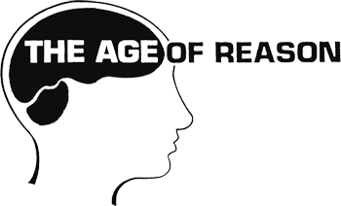
The Enlightenment’s 4 Major Beliefs
Rationalism  Allow religion? Yes or No  Focuses on: | Skepticism  Allow religion? Yes or No  What did it challenge?
Deism  Allow religion? Yes or No  Focuses on: | Imperialism  Allow religion? Yes or No  Based only on:  Foundation of _____________________
Who were the philosophes? (Pay attention to these guys, we’ll come back to them)
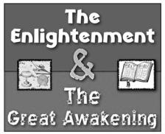
The Enlightenment
- A time of Reason and Science
  - Emphasized _________________ and ________________as a path to knowledge.
    - Based on natural laws of the universe such as gravity.
  - Stressed_________________ or experimenting to understand the ____________.
  - Some applied these natural laws to societies.
  - Ideas about ___________________ rights and government influenced leaders.
- People of the Enlightenment
  - ____________________________
    - An American thinker, diplomat, and inventor
  - ____________________________
    - All men are rational and capable
      - Rights to Life, __________________, and_______________________
    - Governments must work to protect those rights
  - Baron Charles ________________________________________
    - Division of state: Separation of ______________________________
  - William Blackstone
    - Natural rights are adapted to human rights that come from ___________

