- The building up of military strength_____________________
Part 1 Adolf Hitler appeasement Emperor Hirohito expansionism Harry S Truman Homestead Act Isolationism Industrialism Josef Stalin Frank D Roosevelt Merger Militarism Mobilization Nationalism Neutrality Propaganda Progressivism Speculation Trust Union Part 2 Andrew Carnegie Child Labor Ellis Island Franz Ferdinand Monroe Doctrine “no man’s land” Selective Service Act Spanish-Amercan war Winston Churchill Utah Part 3 Japan (1) Japan (2) Nazi Party urbanization vaquero atomic bomb margin dough boys Promontory Point, UT Great Depression (1) Great Depression (2) Herbert Hoover New Deal (1) New Deal (2) 1930s Final Solution Anti-Semitism
- Avoidance of conflict and alliances with other nations____________________________________________
- The process of increasing a nation’s land________________
- Overwhelming support for your country_________________
- A movement towards machines and factories__________________________________________
1
- A joining of competing companies _____________________
- Government program that provided farmland for free______________________________________________
- Buying and selling stocks to make large profits___________________________________________
- Misinformation designed to sway public opinion___________________________________________
- Not taking sides in a conflict__________________________
- To prepare a country for war __________________________
- An organization of companies _________________________
- An organization of workers ___________________________
- Era of reform in the United States______________________
- Giving into Hitler to avoid war_______________________
- Leader of (USSR) Russia during WW2____________________
- US President at the start of WW2_______________________
- Leader of Germany during WW2________________________
- US President who dropped the Atomic Bomb______________
- Leader of Japan during WW2___________________________
- ____________________made a fortune in the steel industry
- Prime Minister of Britain during WW2:___________________
- The Fair Labor and Service Act outlawed_________________
- This was a warning to European countries to stay out of the Americas (Western Hemisphere) _______________________
- Most European Immigrants entered the USA through _________________________________________________
2
- The USS Maine blew in Havana Harbor, starting this war______________________________________________
- The area between Germany and France in WWI _____________________________________________
- Transcontinental Railroad was completed in this state______
- His assassination started World War I ___________________
- This law registered men to serve in the in army ___________
- CCC/Tennessee Valley Auth/Agricultural Act are part of the _________________________________________________
3
- Writers who wrote about the poor conditions in cities__________
- Stock Market Crash 1929 started the _______________________
- Belief that America should stay out of WW2 _________________
- This ship was sunk, leading USA to WWI_____________________
- Who attacked us December 7, 1941?_______________________
- Hatred and Prejudice toward Jews_________________________
- Decade of the Great Depression___________________________
- Jews, Political Enemies and Handicapped/Undesirables were murdered as part of the _________________________________
- USA entered WW2 because Japan attacked _________________
- Italian Dictator called “Il Duce” by his people_________________
- Spanish term for “cowboy”_______________________________
- Information designed to sway public opinion_________________
- The Manhattan Project built the ___________________________
- JD Rockefeller made a fortune in the ________________ industry
- Buying stocks by paying for only part of it is “buying on _______”
- A tax on imported goods is called _________________________
- WWI US Soldiers were called _____________________________
- WW2 dictator fought in WW1 _____________________________
- Transcontinental Railroad was finished here _________________
- Government boarding schools were used to educate __________
- The President blamed for the Great Depression_______________
- FD Roosevelt’s plan to end the Depression___________________
- Growth of cities is called _________________________________
- US dropped the Atomic bomb on ______________to end the war
- Hitler was head of the ___________________________________
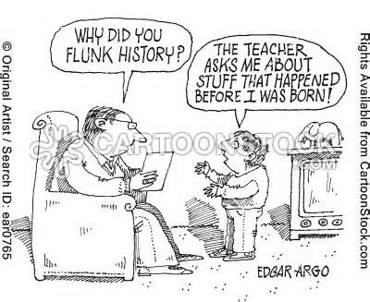
- Farmers left the Great Plains during the Great Depression was __________________
Part 3 Tariff Oil Propaganda Benito Mussolini Native Americans muckrakers Adolph Hitler isolationism Lusitania Dust Bowl Pearl Harbor

- Japan, Germany, & Italy made the _________powers of WW2
4
- President Wilson’s plan for post WW1 Europe ____________
- June 6, 1944 was called ________________________ by their Allies.
- Government where the leader controls all parts of life __________________________________________________
- Statement warning Europe to stay out of America __________________________________________________
- Mussolini’s political party _____________________________
- Germany angered many countries by using _______________
- Anschluss describes when Hitler re-united with ____________
- Work stoppage designed to pressure businesses___________
- Organization of workers for mutual benefit_______________
- WWI: gaining power by controlling other regions___________
- Part of Czechoslovakia Hitler occupied__________________
- Growth of cities is called _____________________________
- Adolf Hitler’s political Party____________________________
- This weapon was first used in WW2_____________________
- Hitler invaded this country to start WW2_________________
- Blitzkrieg means_____________________________________
- European immigrants entered the US through_____________
- Not taking sides in a conflict___________________________
- Henry Ford was the first to use the _____________________ on a large scale
- During the Holocaust, what religion was targeted? _________
- These laws forbade helping nations at war in WW2 __________________________________________________
- Prohibition outlawed_________________________________
- The MAIN causes of WW1 were (4 answers) ______________ __________________________________________________
- Japanese Americans spent WW2 in _____________________
- Who was assassinated to start WW1?____________________
- WW2 took place during these years_____________________
- Tuesday Oct 29, 1929, the day the stock market crashed____________________________________________
Franz Ferdinand
Internment camp
Lightning War
Monroe Doctrine
Strike
Sudetenland
Submarine warfare
Nazi Party
Totalitarian
Urbanization
union

Fourteen Points
Imperialism (1)
Imperialism (2)
Jewish
Japan
Militarism
Nationalism
Neutrality Acts
Neutrality
Part 4 Axis
Alliances
Austria
Alcohol
Assembly Line
Atomic Bomb
Black Tuesday
1939-1944
D-Day
Ellis Island
Fascists

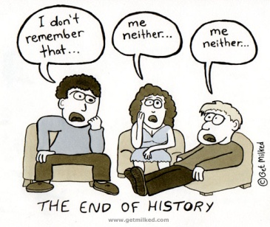
Study!

