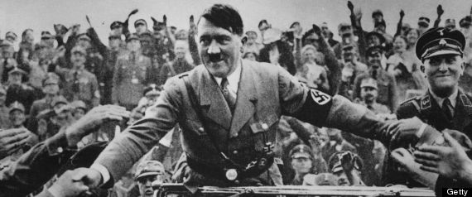
The Rise of Hitler
After World War I, many Germans, including Adolf Hitler, were humiliated. Though never having lost a battle, the German Army surrendered and the entire country was forced to swallow the bitter terms of the Treaty of Versailles. These terms included:
- The War Guilt Clause—accepting blame for causing WWI.
- Reparations—Germany would have to pay for the $64 billion cost of the war.
- Disarmament—German Military was reduced to just one small army, 6 naval ships, no tanks, no air force, no submarines, and, to protect France, all military had to leave the Rhineland.
- Loss of Territories—German colonies were given to other countries and Germany would never be able to unite with Austria again (known as Anschluss).
Such humiliation and embarrassment was hard to accept; how could an undefeated Germany be coerced to suffer like this? Clearly someone had stabbed the Germany in the back, traitors home in Germany—weak leaders, Communists, and most importantly, to Hitler, the Jews.
In his years before politics, Hitler was an impoverished wanderer, a failed artist, a leaf floating and flitting aimlessly across the German landscape. But World War I changed that. Adolf Hitler, decorated with two Iron Crosses for bravery, could not stand for such a humiliating post-war existence. His frustrations had created a cause and an enemy. He merely lacked direction.
The Great Depression which had crippled the United States also devastated Germany, but Germany’s problems started in the 1920s. Unemployment was devastatingly high, food was expensive, the people were desperate and frustrated with their leaders. It was in this turmoil and despair that Hitler found his direction. Clearly the people needed a stronger government. He first tried to take it over violently, and failed. The attempt to overthrow the country gave Hitler the national spotlight. He was arrested and wrote his thesis Mein Kampf (My Struggle) while in prison.
The book revealed his obsessions—extreme nationalism, racism (against slavs), and anti-Semitism. Germans, he said, belonged to a master race of people—the Aryans—light skinned Europeans whose greatest enemy was the Jews. He blamed Germany’s defeat on Jewish and Communist conspiracies. He urged Germans everywhere to unite. Germany needed to expand, he said. It needed Lebensraum, or living space, for its people.
To a German people suffering and lost in hopelessness, Hitler’s message at least gave them something to be proud of and, at most, gave them someone to blame and a purpose. The Nazi Party’s popularity began to grow, and Hitler was elected Chancellor of Germany (the country’s second most powerful job) in 1933. Within a year, he would become dictator, Der Fuhrer, of Germany. Nothing would be the same again.
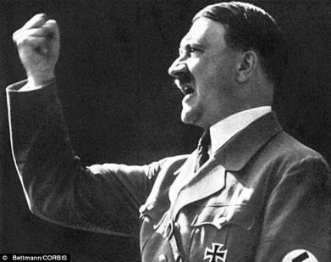
Hitler in Power
When Adolf Hitler became Chancellor of Germany in 1933, he began to build the machine that would almost take over the world. Such ambitions would not be limited to the rules laid out in the Treaty of Versailles. Almost immediately he began rebuilding Germany’s armies and weapons in secret. In 1934, he increased the Army’s size, built warships and an Air Force, and he introduced compulsory military service—every male was legally required to serve in the military.
The Rise of Fascism Fascism is a political philosophy in which total power is given to a dictator while individual freedoms are denied. Often an extreme, racist form of nationalism is emphasized. Fascist leaders of WWII included Hitler, Benito Mussolini (Italy), and Hideki Tojo (Japan). These dictators came together and formed the Axis Powers of WWII. A fascist regime (government) can be very scary. When ruled by a fascist dictator there is no voice for the common man. Whatever the fascist dictator says is law. If he sentences you to death, then death it is—no trials, nor lawyers, nor questions, nor arguments. In fact, even just questioning a fascist dictator will, in all likelihood, get you a death sentence.
For German civilians who supported Der Fuhrer Hitler (the leader in German), it was an exciting time. But those who questioned him had great reasons to be fearful. Hitler and his supporters robbed people of their civil rights and destroyed their political rivals. Now the only political party in Germany was the Nazi Party—but even other Nazis were not safe. Hitler brutally executed Nazis he thought were disloyal, silencing any voice that was not fully committed his vision. The Nazis learned to obey Der Fuhrer without questioning. Germany was a fascist state.
Britain and France (along with the USA) were aware that Hitler had begun breaking the Treaty of Versailles; but they were also concerned about Communism and thought a stronger Germany might help prevent it from spreading to the West. These Western countries decidedly turned a blind eye to what was happening in Germany.
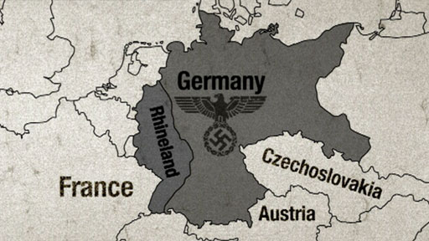
Then in March of 1936, Hitler’s intentions to break the Treaty of Versailles were clear: he ordered German troops to reenter the Rhineland (its borderland with France). At this point, his army was not very strong and could have easily been defeated; yet, no country rose to stop him. There were lots of reasons/excuses why: France and Britain weren’t prepared for war; the Rhineland was just Germany’s “backyard,”ya know?; the Treaty of Versailles was a bit harsh, don’t you think?; Germany learned their lesson last time, Hitler wouldn’t invade another country again, would he?; and anyway, the 1936 Olympics were a few months away—nothing like some good natured competition to ease the tensions! Unfortunately, the western countries were wrong. Hitler was just getting started.
1936 was also the year that Axis Powers began to take shape. Hitler’s Germany allied with Mussolini’s Italy. Then, Germany also formed an alliance with Japan, a country who already successfully invaded Korea and parts of China with brutality and force.
There was still more of that World War I treaty Hitler could break. In 1938, without notice, German soldiers marched into Austria. The Austrian leader was forced to hold a vote asking if the Austrian people wanted to be a part of Germany. The results were fixed, 99% of Austrian people wanted to join Germany, they said. Anschluss was “approved” and Germany annexed Austria. The Austrian leader asked France, Britain, and Italy for help, but Hitler—the liar—promised he would take no more land, and so still the countries did nothing again.
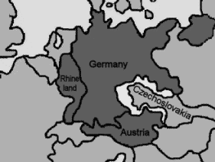
Six months later, Hitler broke his word again and demanded the Sudetenland of Czechoslovakia be turned over to Germany. Hitler’s armies were stronger now, stopping him would be a lot more difficult. Neville Chamberlain, the Prime Minister of Britain, met with Hitler in Munich, Germany to try and avoid war. The Munich Agreement gave the Sudetenland to Germany if Hitler agreed to leave the rest of Czechoslovakia alone. Chamberlain returned to Britain declaring “Peace in our time.” Boy, was he wrong.
Poland
Sudetenland
Hitler was undaunted. In March of 1939, his armies invaded the rest of Czechoslovakia. The Czechoslovak government cried for help, but still no one came to their rescue. Still unprepared for war, trying to stop Hitler now could be disastrous for Britain and France. They needed time to get their war machines caught up, and though they could not know it then, they would only have six months.
The decision to continually give into Hitler in an effort to avoid war was called appeasement. It did not work, however, because in order for contracts, negotiations, or compromises to work, both leaders (Chamberlain and Hitler) must be willing to play by the rules. Hitler clearly was not.
After Czechoslovakia, most of the world knew Hitler should not, could not, and would not be trusted anymore. Poland was most likely Hitler’s next target. Britain and France promised that if a German soldier set foot in Poland, they would take military action against Hitler. Chamberlain believed this threat would be enough to stop the dictator, but Hitler had one more alliance to make. In late August, 1939 Germany and the Soviet Union (Russia) signed a secret non-aggression pact that cut Poland in half. Part would go to Germany, and part would go to the Soviet Union (USSR). German troops invaded Poland on September 1st, 1939.
World War II had begun.
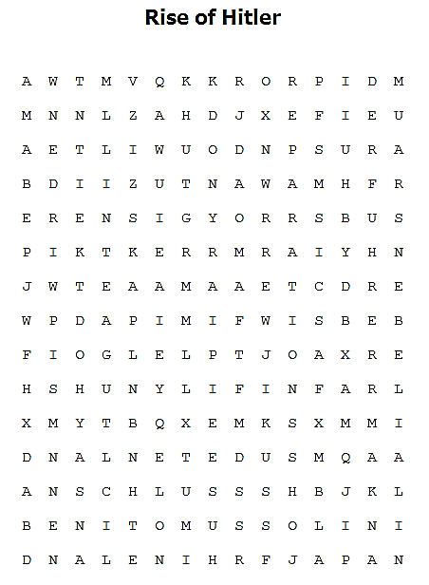
Anschluss Benito Mussolini Fascism
Italy Mein Kampf Sudetenland
Anti-Semitism Der Fuhrer Hideki Tojo
Japan Reparations War Guilt
Aryan Disarmament Humiliated
Lebensraum Rhineland
Rise of Hitler
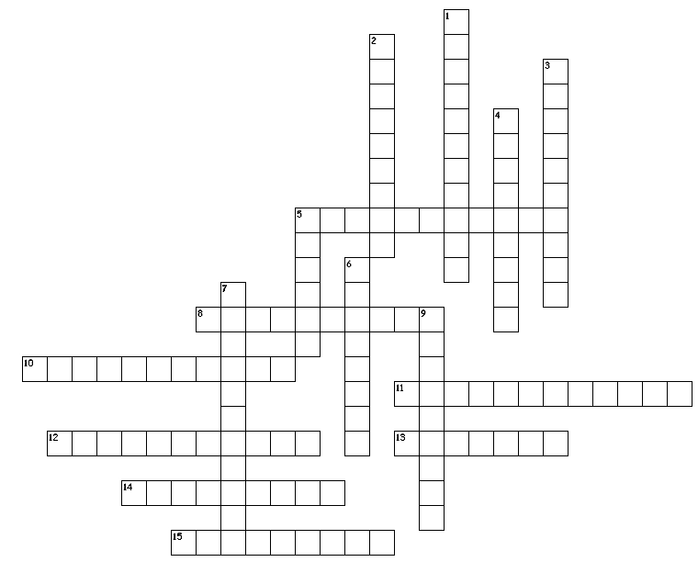
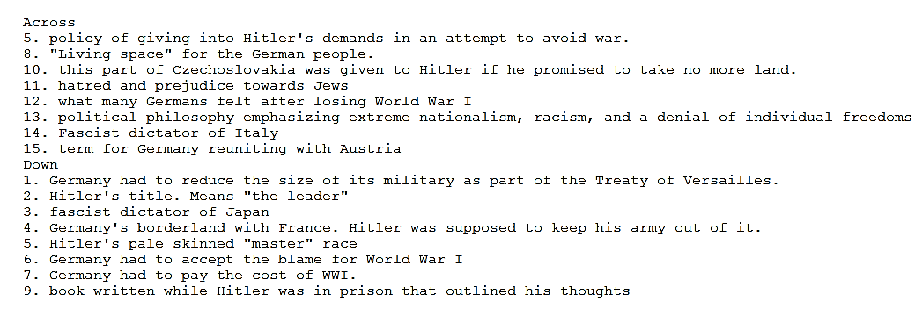
Connecting to the Past: What historical world events that we have studied might have contributed to why Britain and France chose to appease Hitler?
Connecting to the Present: Pretend there is a leader of a powerful country. Her country borders another where many people who live there speak the same language and have the same traditions as her country. She says she wants to take just the land areas where these people live into her country. Should we allow her to do this? Why or why not?

