- The New Deal was:
  - The programs and policies of FDR to help end the Great Depression.
  - The way investors purchased stock “on margin.”
  - Herbert Hoover’s attempts ease suffering during the Great Depression.
  - The term to describe buying goods on credit, giving people a “new deal.”
- In which year did the Great Depression begin?
  - 1928
  - 1929
  - 1930
  - 1931
- Who was president at the start of the Great Depression?
  - Woodrow Wilson
  - Herbert Hoover
  - Franklin D. Roosevelt
  - Al Capone
- What event basically started the Great Depression?
  - The Dust Bowl
  - World War I
  - World War II
  - The Stock Market Crash
- The Stock Market Crashed on:
  - Black Friday
  - Black Tuesday
  - Blue Thursday
  - Green Wednesday
- About how many Americans were unemployed during the Great Depression?
  - 10%
  - 15%
  - 25%
  - 30%

- The Dust Bowl was:
  - A period of drought, dust storms, and high winds on the Great Plains during the Depression.
  - The central office of President FDR’s New Deal Program in New York.
  - A poor and unclean neighborhood in New York City.
  - The tariff President FDR put on foreign products being sold in the USA.
- All of the following statements about the Great Depression are true EXCEPT:
  - Large numbers of people were without jobs.
  - Large numbers of people registered to vote.
  - Farmers’ incomes fell to very low levels.
  - Large numbers of people were hungry and homeless due to bank and business failure.
- What major event marked the end of the Roaring 20s?
  - The election of FDR
  - Banks going out of business
  - The Stock Market Crash
  - The difficulties of farmers
- How did President Hoover respond to the Great Depression?
  - He created extensive policies to relieve people’s suffering.
  - He asked the army to come in and maintain order.
  - He offered veterans work, food, and a place to leave.
  - He told the people that the government would not directly help the people.
- Which best describes “buying goods on credit?”
  - Buying goods today with money that you will have tomorrow.
  - Buying goods today with money that you had yesterday.
  - Buying goods with money you have.
  - “Renting” items until they are paid for.
- All of the following are causes of the Great Depression EXCEPT:
  - Bad Business/Overproduction
  - Bad Banking
  - Stock Market Crash
  - The Dust Bowl
- The major cause of the Dust Bowl was:
  - Ripping out the native grasses for farming.
  - A terrible drought.
  - High winds.
  - All of the above.
- The single event that led America out of the Great Depression was:
  - The Roaring 20s.
  - World War I
  - World War II
  - Nothing; we are still depressed
- How did FDR try to restore Americans’ faith in banks?
  - He closed them for 3 weeks on a “Bank Holiday”
  - He created the FDIC which protected money deposited in banks.
  - Both A and B
  - None of the above.
- All of the following happened to those in Dust Bowl EXCEPT:
  - Many of them chose to leave.
  - Children and the old died of lung complications.
  - Many of the stayed and stuck it out.
  - All of the above.
- FDR able to beat Hoover so easily in the election of 1932 because of all of the following EXCEPT?
  - His opponents called him cruel and uncompassionate.
  - FDR used his family money to buy the election.
  - Americans were angry that Hoover didn’t help them.
  - All of the above were reasons.

For the next two questions, look at the chart below.
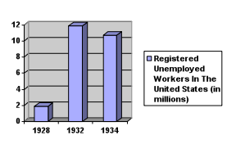
- How many more registered unemployed workers were there in 1932 than 1928?
  - 12 million
  - 14 million
  - 10 million
  - 9 million
- Based only upon the information shown in the chart above, which year during the Great Depression was the worst for unemployment?
  - 1928
  - 1929
  - 1932
  - 1934
TRUE OR FALSE.
- Hoover and FDR had very similar backgrounds.
- The New Deal helped give people jobs, but most Americans felt FDR was still doing too little.
- During the First 100 Days, FDR did very little in terms of passing laws.
- The Tennessee Valley Authority built dams and provided electricity to many southern homes.
- Herbert Hoover was as successful engineer before he began his life in politics
- The Hoover Dam was built during the Great Depression.

For the following 4 questions look at the images and answer the questions based on what you see in the photograph or artwork.
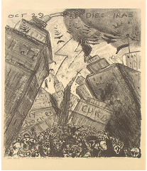
- Based on the picture above, which event is it representing?
  - The New Deal
  - The Dust Bowl
  - The start of WW II
  - The Stock Market Crash
- Which term best describes the image below?
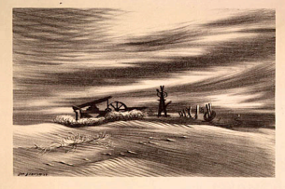
  - The new Deal
  - The Dust Bowl
  - The start of WWII
  - The Stock Market Crash

SHORT ANSWER.
- Describe in detail: One of the causes of the Great Depression and how it helped create the Depression.

- Describe how Hoover and FDR’s backgrounds were different.

- Explain how humans gradually (Native American to Ranchers to Farmers) created the Dust Bowl.

