Adapted from a History of Us

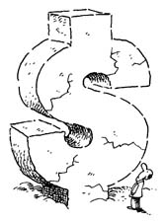

Get Rich or Die Trying… Boom and Bust in the Stock Market Crash 1929

In 1927, ’28, and ’29 it was easy to get rich. All you had to do was a put a little money in the Stock Market. Then you could watch it turn into a whole lot of money. Here is how it worked.
Imagine that you are the owner of a large company: ABC Cell Phones. You make smartphones, good smartphones, and you want to expand. You want to make new generations. You need to build a new factory and buy a lot of equipment. You need money. So you decide to look for investors and sell shares of your company. You sell 10,000 shares at $100 each. The shares are called stock. Anyone who buys that stock becomes a part owner of ABC Cell Phones.
The new generation Smartphone is a huge success. The company earns tons of money and the stock-holders get a percentage of the profits. These are called dividends. Everyone wants to buy shares of your company, but since there are only 10,000 shares available (It sounds like a lot but it’s not). People are willing to pay more than the $100 you asked for. Some pay $110. Then they pay $120. Soon ABC stock is selling for $200 a share.
One stockholder, Mr. NeCamp, bought 10 shares for $100. Now he will sell them for $200 each. How much money did he make?

Pretty easy money, isn’t it? But wait, it was even easier in the ‘20s! People bought stocks on margin. This means they borrowed most of the cost of a share (Today laws don’t allow you do this). Margin means you don’t have to pay the full value of the $100 for $100 worth of stock. You can pay $10 and your stockbroker will loan you the rest. You’ll have to pay him back, but it’s no big deal because you can do that once ABC stock rises in value a little more, making you both rich!

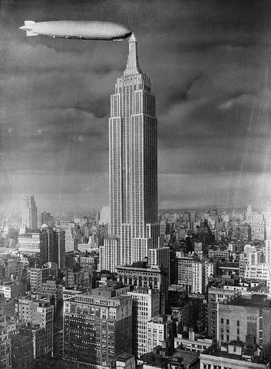Plans to build the Empire State Building (for many years the tallest in the world) began at the height of the stock-market boom. By the time it was completed in 1931, though, half of the floors were empty because there were no businesses to occupy them.

In 1928, everyone was swinging to the upbeat tempo of the Jazz Age. A year late though, there was little to dance or be upbeat about. Depression songs were titled: “I Got Plenty o’ Nuthin’” and “Shanty in Old Shanty Town.”
This business of buying and selling stock is called the stock market. The place where they are bought and sold is the stock exchange, and the most important one is in New York City, on Wall Street. Stockbrokers from all over the world call Wall Street with orders to buy or sell.
If business goes well, stocks (their prices) go up. If business suffers, stocks go down. Around 1924 the stock market began to rise, slowly at first, but then quicker, and quicker. In 1927 the market began to rise furiously. Some stocks seemed double, or even triple, almost overnight. Everyone was talking about it. Newspapers wrote about it. Political leaders patted themselves on the back. They felt it was their guidance and leadership that caused it. Business leaders were happy too. Clearly their business brilliance was causing the Stock Market boom. Politicians and business leaders said it would never stop; we would just keep getting richer and richer. Even college professors agreed. It was like the ATM of our economy was broken and just spitting out cash!
Now imagine you are a regular, hardworking person. You decide to cash in in the stock market as well. You take your savings--it’s not much, but it’s all that you have—and buy some stocks. You decide to buy on margin. It’s what the experts say to do, get the most shares for your money. And at first, things are good. Actually, they’re great! Some people buy stock without even caring if the business is good or not. Stock equals free money; more stock equals more free money. Stock. Stock. Stock! I want more stock! I want to be rich!
But nothing is really free, is it?
What would happen if everyone sold their stock at once? Picture a balloon being pumped up. Now watch the pin…
It happens in October 1929. It is called the panic. People go wild trying to sell. No one wants to buy.
Remember that $100 stock you bought on margin for $10? Well when the price drops, you lose your $10. But it’s worse than that. You didn’t just buy one share. You spent your entire life’s savings on as many shares as you could. Not only that you still owe $90 for each share you bought to the stockbroker.
So, not only are you out your life savings, you owe more money than you’ve ever had!
Sorry, but you have to still have to pay. You don’t have the money? You can sell your house, or your car, or both. I don’t care, you still have to pay.
Oh, you lost your job, too? You worked at ABC Cell Phones. That’s too bad. People have stopped buying smartphones. Now the company is losing money. They had to sell that new factory you worked at.
And you know about the banks, don’t you? The banks are all in trouble, too. You see, they lent money to the stock brokers to pay for all the people buying on margin. Where did that money come from? From the people who didn’t trust the stock market, the people who just wanted to keep what they had earned the hard way. But now their money is gone. All the money is gone—poof, vanished—and the banks are closing their doors for good.
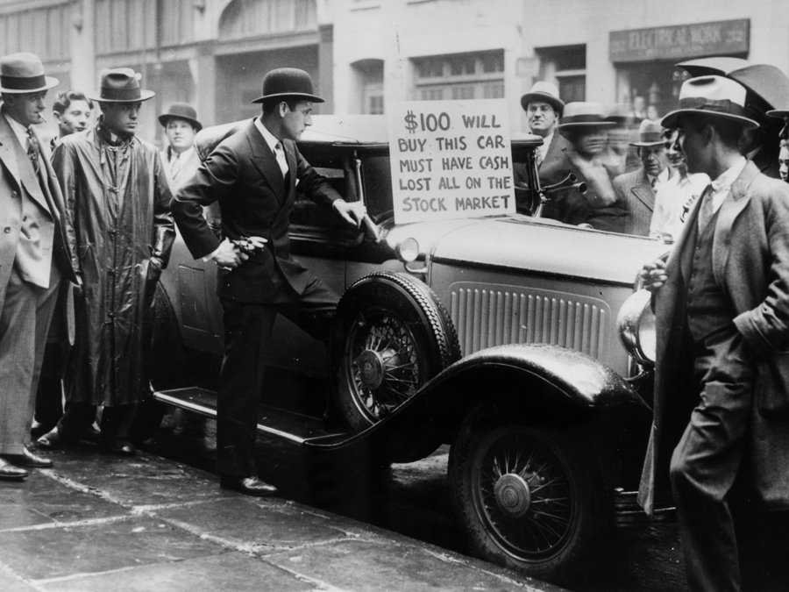
What is happening in America?
It’s the start of the Great Depression, that’s what. Soon people had good jobs will be selling apples on the street for a nickel a piece.
It will go on for 10 years. People out of work for 10 years. Hungry, 10 years. Homeless, 10 years. The country will be in terrible shape.
But boy those twenties were great, weren’t they…

