Name:____________________________________________
ACROSS
3. name given the fighting that took place in Europe 6. The Battle of the _____ was Hitler’s last attack. 8. June 6, 1944 (D-Day) Allied forces invaded here. 9. The plan was to invade through this island and Italy 10. This battle was a turning point in the war--Nazis v. USSR
DOWN
- He was the Supreme Allied Commander
- Celebrated the day after Germany officially surrendered
4 This dictator committed suicide rather than face arrest 5. This dictator was killed by his own people. 7. The largest military invasion ever
EUROPEAN THEATER
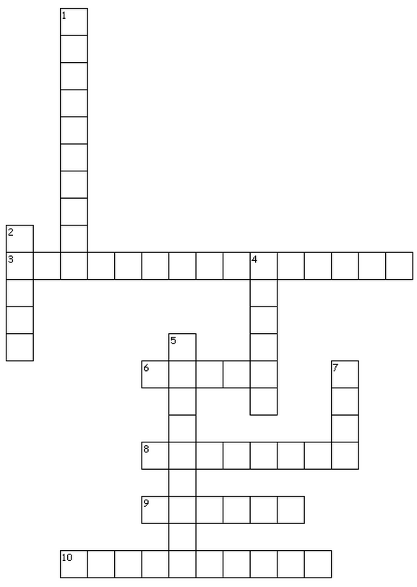

Name:____________________________________________
ACROSS
3. name given the fighting that took place in Europe 6. The Battle of the _____ was Hitler’s last attack. 8. June 6, 1944 (D-Day) Allied forces invaded here. 9. The plan was to invade through this island and Italy 10. This battle was a turning point in the war--Nazis v. USSR
DOWN
- He was the Supreme Allied Commander
- Celebrated the day after Germany officially surrendered
4 This dictator committed suicide rather than face arrest 5. This dictator was killed by his own people. 7. The largest military invasion ever
EUROPEAN THEATER
ACROSS
3. name given the fighting that took place in Europe 6. The Battle of the _____ was Hitler’s last attack. 8. June 6, 1944 (D-Day) Allied forces invaded here. 9. The plan was to invade through this island and Italy 10. This battle was a turning point in the war--Nazis v. USSR
DOWN
- He was the Supreme Allied Commander
- Celebrated the day after Germany officially surrendered
4 This dictator committed suicide rather than face arrest 5. This dictator was killed by his own people. 7. The largest military invasion ever

