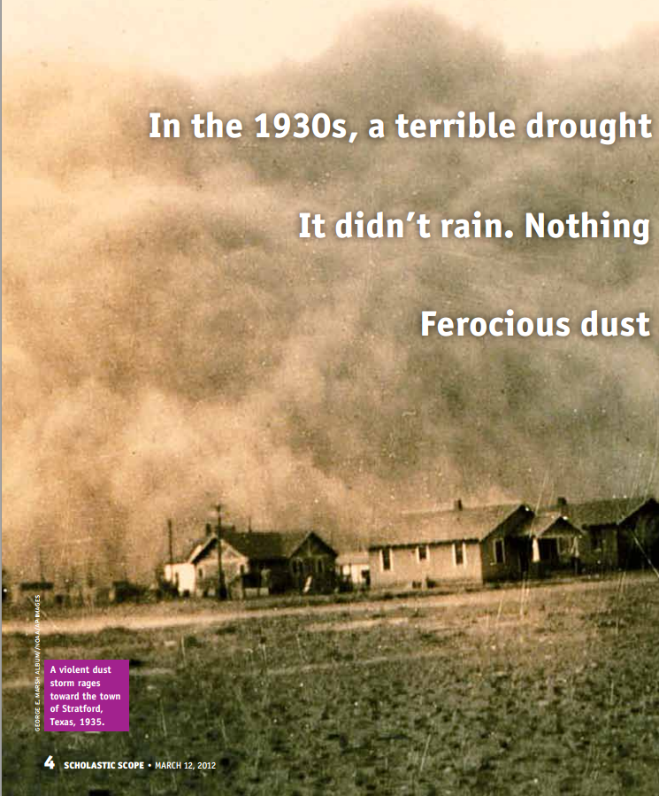

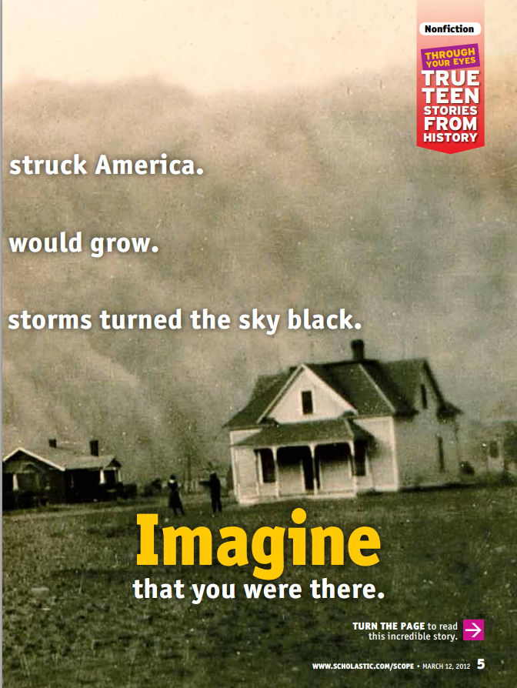

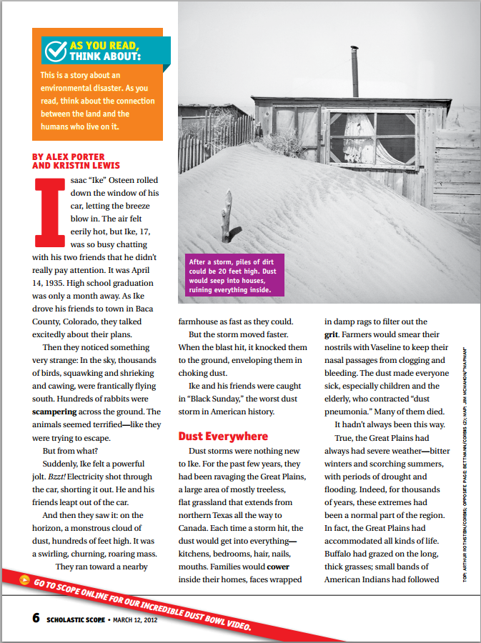
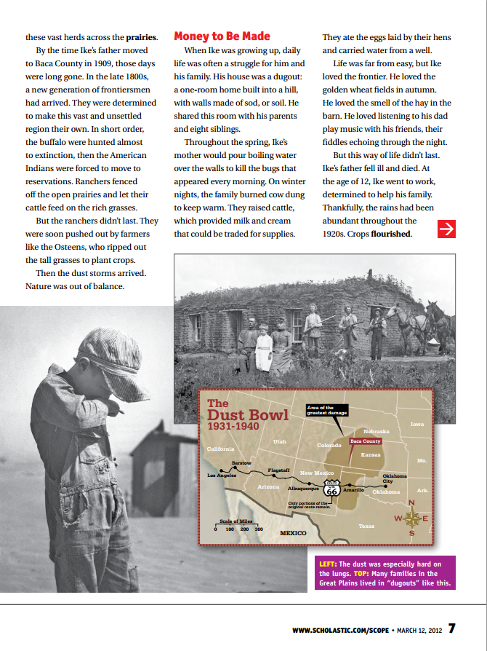
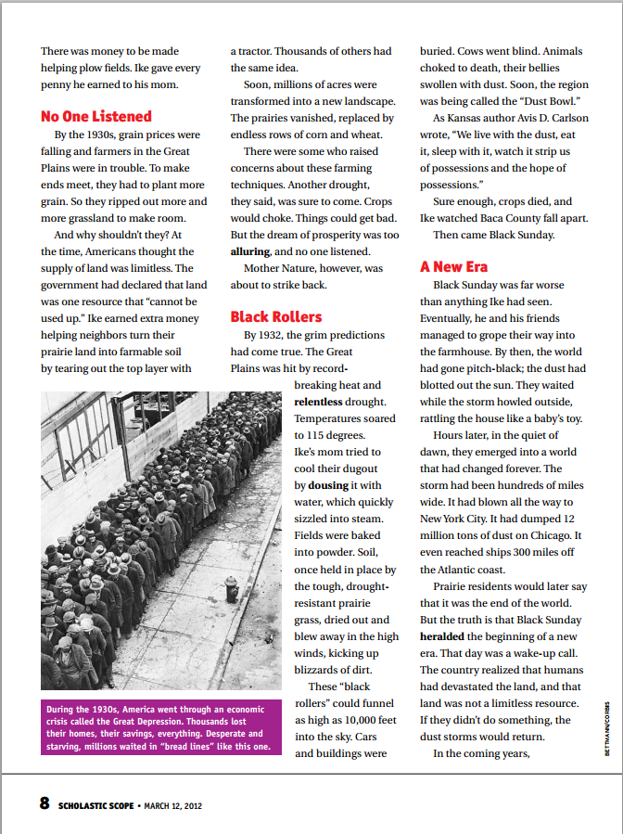
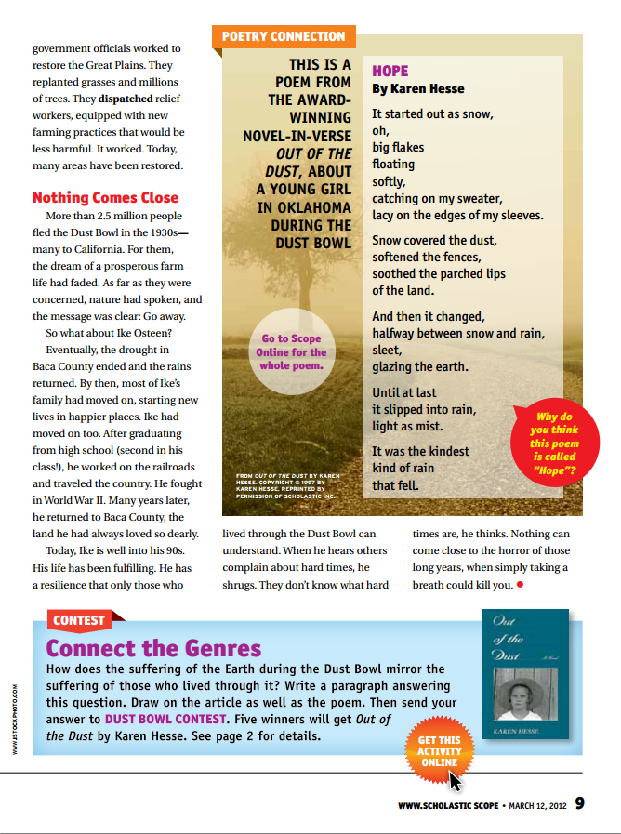
- Describe how the natural balance of the Great Plains changed from the eras of Native Americans to Ranchers and eventually to Farmers.

- Why did farmers rip out even more of the natural prairie grasses?

- Why was ripping out the grass a bad idea?

- Describe the damage a “black roller” could cause.

- List three facts about Black Sunday that you learned in the reading.

- Why did 2.5 million people flee the Dust Bowl?

- Why do you think the poem on page “9” is titled Hope?

