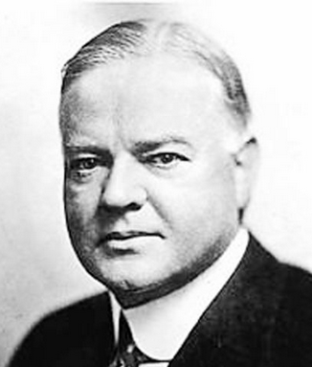
A Tale of Two Presidents
HERBERT HOOVER. President Herbert Hoover was probably the best prepared and most qualified of the three 1920s presidents. Born in 1874, he knew poverty personally. His parents died when he was young, and Hoover was raised by two uncles. Unable to afford to send him to college, Hoover worked himself through college. For some time he worked in coal mine for $2.50 a day. In school, at Stanford University, he studied engineering and proved such a good mining engineer that he made a million dollars before turning 40. He then decided to use his skills in government service and charity. During WWI, Hoover organized aid efforts for people suffering in Belgium, later serving as the head of the US Food Administration and Secretary of Commerce under three different presidents.
Hoover became the Republican Presidential nominee in 1928 declaring, “We in a America are near-er to [ending poverty] than ever before in history.” Yet within months of his election the stock market crashed, and the nation spiraled downward into depression.
The Depression affected Europe as well and by 1931, Europe’s problem deepened our crisis. Farmers all over faced foreclosure, states had no money to feed the unemployed, and there were no new jobs in sight.
At the same time that Hoover declared people must not suffer from hunger and cold, he said that caring for them must be done on the community level and voluntarily. The government would not directly ease the people’s suffering. Many Americans who wanted the government to take care of them were outraged.
During the 1932 election, Hoover’s opponents portrayed him as cruel and uncaring. Most of America blamed him for the Depression and he was defeated by Franklin D. Roosevelt.
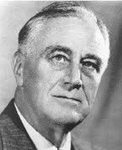
FRANKLIN D. ROOSEVELT. Franklin D. Roosevelt (FDR) was born into a wealthy life of privilege. He was homeschooled by private tutors until he was 14. He then attended an elite, private high school where he earned average to low scores. His classmates believed he would probably not amount to much. Roosevelt then attended Harvard University, graduating with average, though unimpressive grades. He attended law school and became a lawyer, but never finished his classes.
Following the example of his distant cousin, former President Teddy Roosevelt, FDR entered a life of politics. Using charm, connections, and a good chunk of family money, he got himself elected to the New York Senate at the age of 29, and eventually an appointment on President Woodrow Wilson’s staff.
In 1921, at the age of 39, disaster hit—he contracted polio. With considerable determination FDR was able to regain the use of his legs and political career, though would never be able to walk without the support of leg braces again.
Taking the Presidency in 1932, at the depth of the Great Depression, Franklin D. Roosevelt helped Americans regain faith in themselves and brought hope, action, and the declaration that “the only thing to fear is fear itself.” He spoke casually to the people through the radio—the first President to do so—and was embraced for it. His first “hundred days” of office was the most intense period of lawmaking in the history of Congress. Fifteen new bills—and with them the New Deal—was proposed. Social Security, heavier taxes on the wealthy, and massive work relief programs for the unemployed were created.
Americans loved him and reelected Roosevelt to 3 more terms, leading the country for a total of 12 years—throughout the Depression and into WW2. He will be the only President to serve so long.

