Name: ___________________________________________Pd______
Background: During the American Revolution, the colonies needed to not only coordinate their efforts against the British, but also create a government to ask for help from—and eventually repay—powerful European countries. The colonies created an emergency government called The Continental Congress. After the Revolution, the Americans were officially free from Britain, but the countries that helped us (France and Spain) were expecting to be repaid. The system of government they created, the first for these newly free Americans, was called the Articles of Confederation. The new national government was designed to be weak. Rather than having a strong government that tied all states together as American, the Articles of Confederation described itself as a firm friendship between independent states. It was approved by the states on November 15, 1777.
Articles of Confederation
On our class website, click the link to watch the BrainPop video on the Articles of Confederation. Take the “Review Quiz” to help you answer the questions.
- What was established by the Declaration of Independence? ___________________________________
- What convinced the framers of the Articles of Confederation to create a weak central government? ____________________________________________________________________________________
- Under the A of C, why might a state tax goods made in another state? __________________________ ___________________________________________________________________________________
- The biggest obstacle the Confederation faced was __________________________________________
- What phrase best describes federalist systems of government? ________________________________
Examine the Table below closely, then answer the questions that follow.
The Articles of Confederation
Structure | - One branch of Government: Congress, responsible for making laws  - Each state had one (1) vote in Congress  - No Executive (no President)  - No Judicial Branch (no Supreme Court) to decide if any laws are unfair.
Decision Making | - 9 out of 13 states (9/13) needed to approve suggested laws for them to become real  - ALL the states had to agree to change an existing law.
Money and Finances | - Articles of Confederation could not collect taxes  - A of C had to ask individual states for money  - A of C could print money and borrow money from other countries  - Each state could regulate trade with other states.  - Each state could tax its residents.
Protection | - A of C managed treaties with other countries and Native Americans.  - A of C could appoint military leaders  - No national army; only state militias
Other | - Created: post office; standard weights and measures, courts, and handled piracy

- Leanne Keene, French Ambassador, arrives from Paris to tell you France needs the money it lent the colonies during the Revolution immediately. Can the Articles of Confederation solve this problem? Explain.

- A large group of poor farmers in Massachusetts is angered by war debts, bad harvests, and high taxes. When their debt-ridden farms are taken by the bank, they march on the state capital in protest. Massachusetts sends their militia to control the situation but it is outnumbered and they ask Congress for help. Can the Articles of Confederation solve this problem? Explain.

- Some states have abolished slavery in their own constitutions. Two Confederation delegates, Nevin Weinberg and Dani Kwatcher propose an amendment to abolish slavery in the entire country. Can the Articles of Confederation solve this problem? Explain.

Examine the Cartoon below, then answer the questions below.
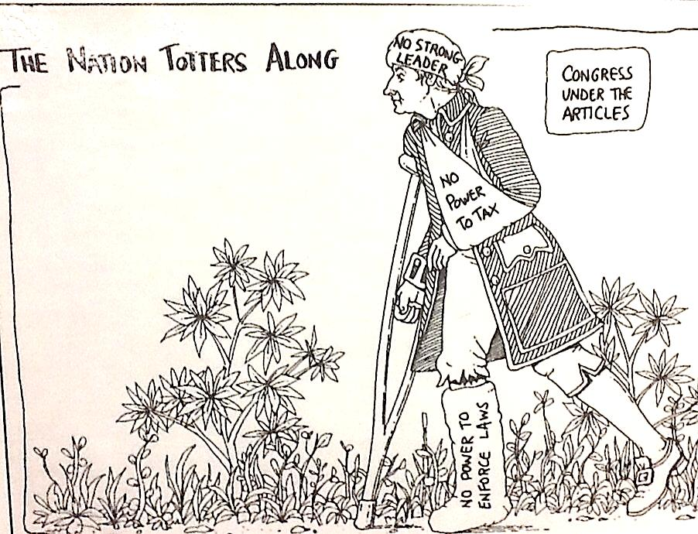
- Who does the man represent?

- What are the causes of his “injuries?”

- Does this cartoon support or criticize the Articles of Confederation? Explain.
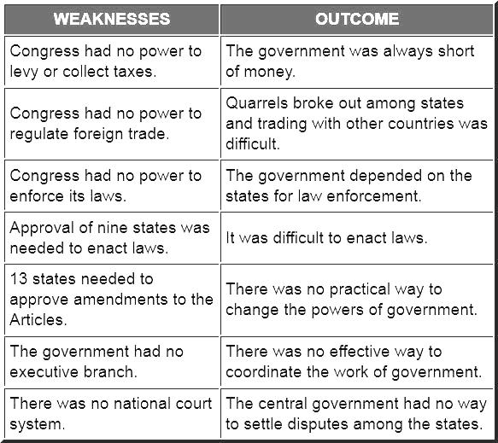
- What happened because Congress could not regulate foreign trade?

- Why is it important to have a President/Executive?

- Why was is so hard to approve amendments to the Articles?

Grading the Government: The Articles of Confederation Based on what you have learned about the Articles of Confederation, give the new American government a grade for each of these basic governmental tasks. Be sure to explain why you gave it that grade and/or specific ways the government could change to make improvements to they grade.
Subject | Grade | Reasons for grade/Suggestions for improvement
Raise Taxes
raise enough taxes to keep an army and pay debts
Pass Laws
create a system to pass laws that is not too difficult
Amending Constitution
Create a process for changing the constitution that is not impossible
National Affairs
Keep order. Earn respect of states and people.
Foreign Affairs
Gain respect of the world. Create treaties fair treaties.

Shay’s Rebellion
During the American Revolution, many farms had to borrow money to make ends meet, and at first food production was low, costs were high, and it was no issue. After the war though, when thousands of farmer/soldiers returned home, production increased and costs dropped. Add to the mix a drought by mother nature, an unsympathetic state government, and an overly righteous debtors' prison system, and you have the ingredients for Rebellion.
Farmers in western Massachusetts were especially hard hit, and they began to fight back. First, they closed courts to prevent judges from taking foreclosed land. Then, Daniel Shays, a Revolution War Veteran, organized 2,000 farmers into a makeshift militia. They attacked courthouses and tried to take warehouses full of weapons. The Governor of Massachusetts sent his own state militia to stop the rebellion and even called on the national Congress to help. But there was nothing the national Congress could do. The state militia eventually won, but it was a very scary moment.
Shays' Rebellion seemed to show the fatal flaw of the Articles of Confederation: if a state wasn't able to handle a problem, there was no one else to ask for help. George Washington and other respected leaders feared the Articles of Confederation gave the government too little power to effectively maintain order in the land. Many Americans were calling for a change.
How did Shays' Rebellion reveal the fatal flaw in the Articles of Confederation? ____________________________________________________________________________________________________________________________________________________________________________________________________________________________________________________________________________________________________

